- Feature file 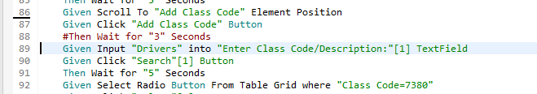

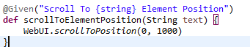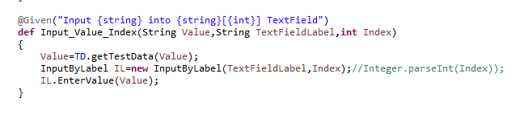

3.click on NCCI

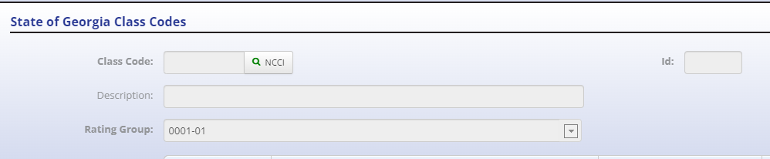

4 pop up screen
